Hello Everyone,

Below is my Use Case Diagram for this discussion.

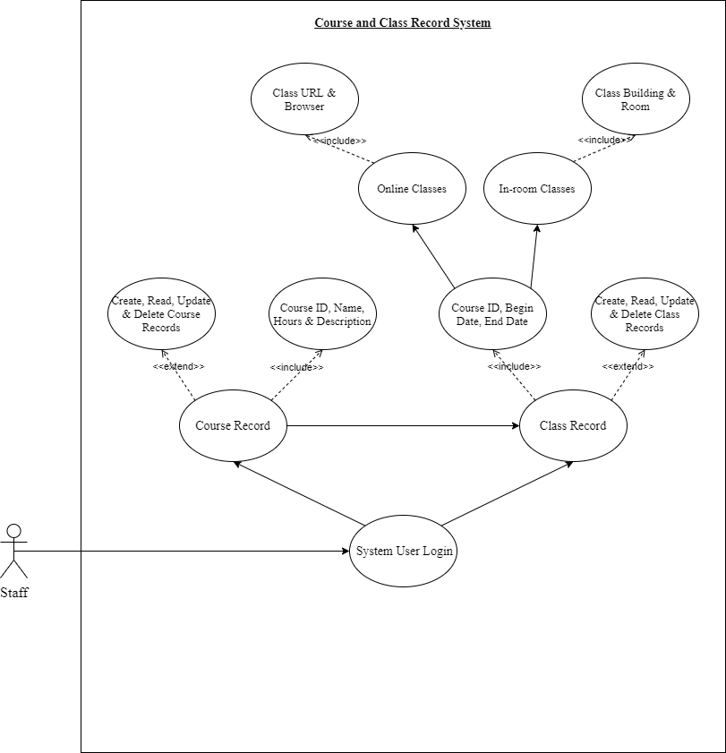

First, the Staff member is outside of the square and the Use-Cases are inside the square because it shows the Staff member is outside of the system while the Use-Cases are in the system. Next, The Staff Member enters the Course and Class Record System (CCR System), which the relationship is shown from the Staff to the System User Login. The Staff member than has access to Course Record and Class Record areas of the system. I also showed that a Class Record cannot be created unless it has a Course relationship to it prior to its creation. The Course Record <<includes>> the attributes Course ID, Name, Hours & Description. The Course Record also has an <<extend>> to allow the staff member the option to Create, Read, Update & Delete a Course Record. The <<extend>> gives an optional behavior to the Course Record Area of the system.

The Class Record also has an <<extend>> to allow the staff member the option to Create, Read, Update & Delete a Class Record. The <<extend>> gives an optional behavior to the Class Record Area of the system. The Class Record <<includes>> the attributes Course ID, Begin Date & End Date. I also showed the attributes of the Class Record has different types such as Online Classes and In-room Classes. The Online Classes <<include>> the attributes Class URL & Browser and the In-room Classes <<include>> the attributes Class Building & Room. These show the Staff member the location where each individual class will be held for attendance.

I created this diagram because if I wanted to update this diagram from CCR System to a Student Information System, I could easily add additional symbols and information. I would place the student as the secondary actor. I would use colored arrows to show which areas of the system would be accessible to all users and the areas which would only allow staff members. I could add the Use-Cases for Student Records and Student Registration symbols below the System User Login.

I gain the knowledge about the different types of relationships and symbols each mean different things. We have symbols such as the actor, the square represents the system, and the use-cases inside of the system are representation of some major function for the system. Each symbol means something for example if I used a square instead of an oval for the Use-Case, I would actually be describing a subject and not a use-case. From the video, I learned the actor on the left of the square is the primary and an actor on the right of the square would be a secondary.